Using Volume to Solve Real Life Problems
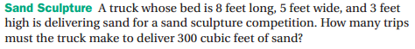

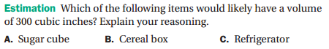
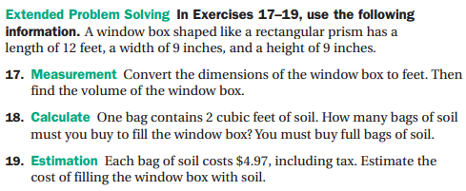

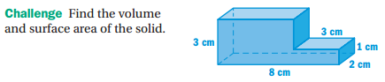

An exotic fish is placed in a rectangular aquarium that has a length of 75 cm and a width of 35 cm. If the water level rises 2 cm when the fish is placed in the aquarium, what is the volume of the fish?

