Equatoguinean for a Day Webquest
- My full name is:

Nombre:___________________ Apellido 1:____________________

- Mark where you are from on the map below.
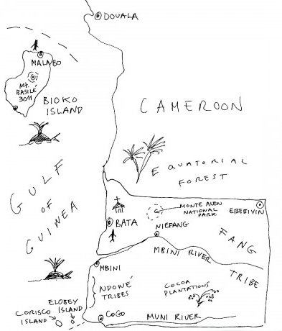
Write 1-2 sentences describing why you choose this city? What is special about it?

Find a picture of your city on google images and post it to your class’s Padlet with the city’s name as the caption.

- El Clima
  - ¿Qué tiempo hace en tu ciudad? ( answer in Spanish!)

  - What is the weather normally like?

  - What do you think you should wear?

  - Post a picture on the padlet of what people where in EG.
- La comida
  - ¿Qué vas a comer en el desayuno?

  - ¿Qué vas a comer en el almuerzo?

  - ¿Qué vas a comer en la cena?

  - Which food looks the most strange to you?

  - Which foods look the most similar?

  - Post a picture of the yummiest or strangest looking plato on the class website with the name of the plato as the caption.

- La Escuela
  - What are three differences between your new Equatoguinean school and your American School?

  - What are three similarities?

  - What do you want to be when you grow up? What kind of schooling would you need to be able to do this in EG?

  - Find a picture of a school in EG on google and post it to the class pad let
- Noticias
  - What are the three most interesting headlines that you have read?
    - Headline 1:

    - Headline 2:

    - Headline 3:

  - Choose one of the headlines above and summarize what happened in 1-2 sentences. Tell how it affects the people living in your city in 1-2 more sentences.

  - Post a hashtag as if you were posting on social media about one of the news events that you read about. Post your hashtag on the class Padlet
- El gobierno
  - What are three similarities between the government in EG and in the US?

  - What are three differences?

  - How do you think these differences affect your life as an Equatoguinean? What is different about your Equatoguinean life because of the way the government runs? (1-2 sentences)

Preguntas!!!
Write three questions for tomorrow’s speaker. Write them first in English if you need to, but then find out how to translate them to Spanish!

