Desk Arrangements

Varied desk arrangements can help make class feel more interesting for students. Also, intentional classroom set ups can be used to enhance the effectiveness of specific classroom activities.

In general it would be wise to have one desk arrangement used per class period so as to avoid unnecessary moving of desks in the middle of the hour. In the event that it is necessary to completely switch the desk arrangement from one class to another, the teacher can put a diagram of the desired desk-set up on the board for students to begin creating as they come into the room, before starting their warm up activity.

General Desk Arrangement for Daily Class (Ms. Maureen Hesslau)- This desk arrangement has the advantage of focusing every student on the front of the classroom where instruction may be taking place, while at the same time giving each student an “elbow partner” who they are easily to work with during group work. This desk arrangement is useful for days that are more presentation-based, but also allow for quick formation of groups because students can quickly turn to their left or right to work with their elbow partner or form groups of four by having rows 1 and 3 turn around to face the two people behind them.

By changing students’ seating assignments throughout the course of the marking period, students will gain the opportunity to work with a variety of different group settings. By causing grouping assignments to be based on seating assignments, students will be forced to get to know people whom they might not know as well, which ultimately contributes to the class having a stronger sense of community as a whole. 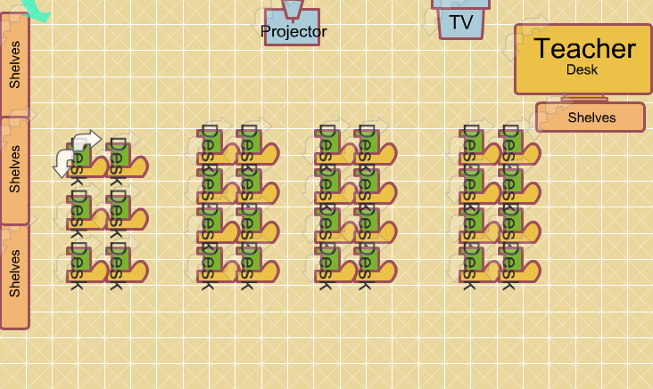

Presentation and Class Discussion Desk Arrangement
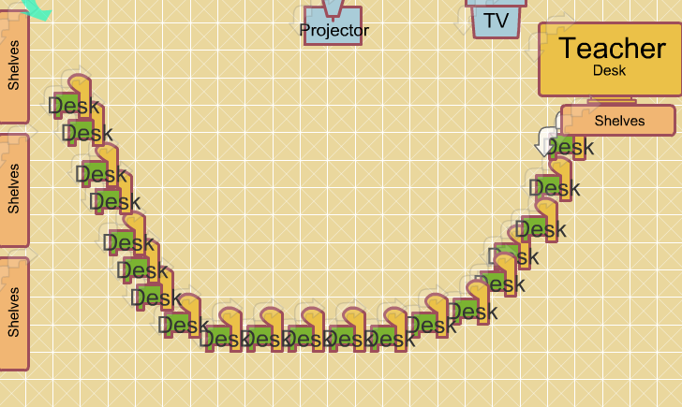

Center Work and Investigation-focused lessons
