Nonlinguistic Representations Applied- Strategy #15
Subject: Spanish
Grade Level: Spanish 2
Time allotted: 55 minutes
Materials Required: Previous vocab lists generated the previous day, sports props (bat, baseball, basketball, volleyball, boxing gloves, baseball glove, running shoes, running shorts, swim cap, dumbbells, swimsuit, other random items), new vocab list, pillow, dress, Geek Squad shirt, “Stud muffin” shirt, guided practice ppt, personal white boards for each student, Olympics activity sheet, homework worksheet
Michigan Curriculum Framework: 1.1.N.RW.k Share opinions and preferences in the target language with their classmates in writing using email messages, notes, letters
Objectives: TLW match the correct Spanish adjective to picture or action; TLW compare people and things in Spanish
Purpose: To better equip students to share their opinions and preferences.
- Anticipatory Set:
  - Using the props in the tub, you have five minutes to create a skit using only the props you see here and the words on your vocab list to make a two minute skit.
  - Allow each group of four to perform skit
  - Reviews vocab from yesterday
  - Have groups pair up and perform for each other while the teacher monitors all of them for the sake of time)
  - Time allotted: 12 minutes
- Purpose:
  - We have been learning about sports and competition. However, what fun is competition if you cannot smack talk a little?! Today I am going to teach you how to smack talk, that is how to tell someone else how your team is better than theirs and make comparisons between two objects
- Instructional Input:
  - Modeling: Strategy #15
    - Teach adjectives through motions. Have students repeat and copy actions
    - Palabras:
      - rápida, lento- do a running motion fast, do a running motion slow (exaggerated)
      - gordo, delgado- puff out cheeks and hold hands like a big belly, suck in cheeks and do ASL sign for thin
      - alto, bajo- stand on chair or tippy toes, crouch down
      - fuerte, debíl- flex, struggle to curl a pencil
      - intelligente- tap head
      - bonita- strike pose and blush. show picture of a princess
      - guapo- strike manly pose. show picture of a prince
      - feo- show an ugly face picture.
    - Demonstrate comparisons between people in class using props to change the way they look
      - stuff a pillow under someone’s shirt for gordo
      - Geek squad t-shirt for intelligente
      - Las pesas for fuerte
      - A dress for bonita
      - “Stud Muffin” shirt for guapo
    - Time allotted: 22
  - Guided Practice:
    - Using the power point provided. Have students write a comparison of the two items or people on their white board and hold it up for the teacher to see.
    - After viewing the students’ responses, give correct answers
    - Time allotted: 10 minutes
  - Independent Practice:
    - Comparison Olympics
      - Have students go around the room “competing” with other students in various activities listed on their worksheet.
      - Have students record competition results on their worksheet
      - Students should then individually write comparisons based on the result of the “Olympic Games”
      - Time allotted: 10 minutes
- Closure:
  - Have students share their responses from the Olympics as a class.
  - Olympics worksheet must checked and approved by the teacher in order to exit the classroom
  - Hand out additional practice for at home
  - Time allotted: 3 minutes
- Assessment:
  - Throughout the entire lesson students will be assessed, for example, during the personal white board exercise and through correctly completing the Olympics activity
  - If they have not yet mastered the objectives by the end of class, seeing this I will be sure to continue reviewing/teaching this same subject the following day.
- Differentiation Considerations:
  - Students who finish early will be able to participate in “free read” from one of our Spanish books in the room. They may also read ESPN.es (the Spanish version of ESPN and read through articles, highlighting all of the words that they know already as vocab)
Nombre y Apellido:_______________________ La Fecha:__________________ Hora:_____________
¡Los Juegos Olímpicos!
Instrucciones: Completa cada competición con diferentes personas. Después, escribe sus resultados en oraciones en forma de comparaciones.

- Arm wrestle someone.
  - Name of person you arm wrestled:
  - Winner:
  - Comparison:

- Measure how high each of you can jump
  - Name of person you competed against:
  - Heights:
  - Comparison:

- Play the “hand-slap” game as demonstrated by your teacher
  - Name of person you competed against:
  - Winner best out of 5:
  - Comparison:

- Designate one person as heads and one person as tails. Flip the coin 5 times to see who is the luckiest (afortunado)
  - Name of person you competed against:
  - Winner:
  - Comparison

Nombre y Apellido:_______________________ La Fecha:__________________ Hora:_____________
Comparaciones (homework)
Instrucciones: Escoge dos de las parejas y compáralos usando vocabulario del clase. Escribe 3 oraciones.
- Barack Obama y Mitt Romney
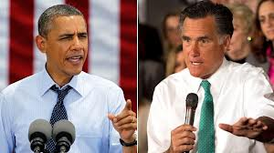
- Cinderella y Belle
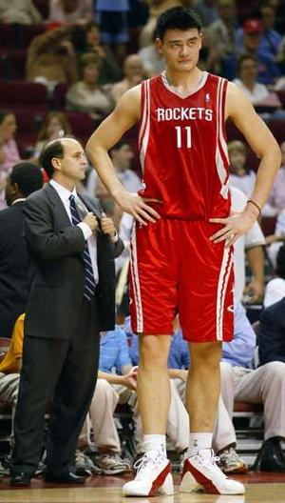
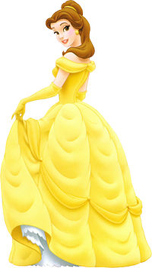
C. Yao Ming y el Hombre

Explanation of Identified Instructional Strategies:
I chose to utilize kinesthetic movement in the memorization of vocabulary since research indicates that memory is added by movement. Additionally, movement helps to keep students alert and can be a fun way to incorporate repetition (a key ingredient for learning) into a lesson without putting students to sleep. While use of other strategies such as using realia, are also valuable, realia is better used to help demonstrate foreign concepts, but kinesthetic movement helps make familiar concepts easier to remember.
When using kinesthetic movement in this instance I will need to be especially mindful of the possible pitfall of allowing students to become too rowdy during movement. To help avoid this issue I will set clear procedures ahead of time as well as establish a stopping signal that I would utilize if things began to get too out of hand.

